Title of presentation

First and second name of authors and co-authors
Affiliations
e-mail address of the presenting author

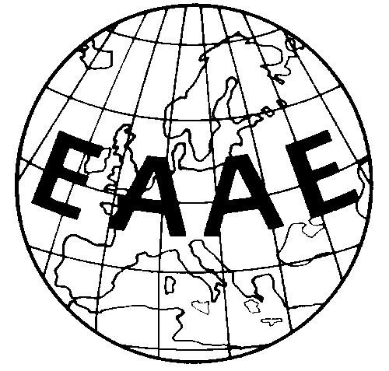

Contribution prepared for presentation at the 187th EAAE Seminar
“Food System Transformation – Role of Research”

June 12-14, 2024
FiBL & Agroscope & SGA

